2.1 algorithm to determine if a number is an even number

>> Start number at 0 (n = 0)
>> input number
>> check if number is even by adding 2 to n
>>if number is not n + 2 up to inputted number say number is not even
>> If number is n + 2 up to inputted number
>>say number is even

2.2 does word have a vowel

>> Enter a word
>> check input for ‘aeiou’
>> If word has ‘aeiou’
>> Say word has a vowel
>> If word does not have ‘aeiou’
Say word does not have a vowel

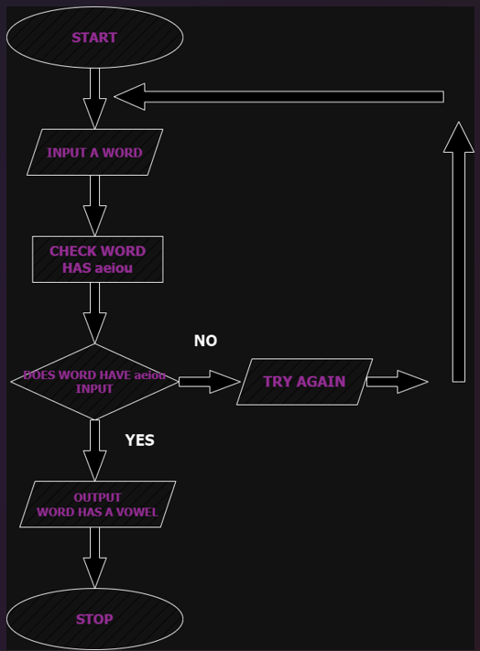

2.3 improved vowel including count

>> Enter a word
>> check input for ‘aeiou’
>> If word has ‘aeiou’
>> If word has ‘aeiou’
>> Set count to n=0
>> For every ‘aeiou’ count n + 1
>> Say word has n+(1) vowels

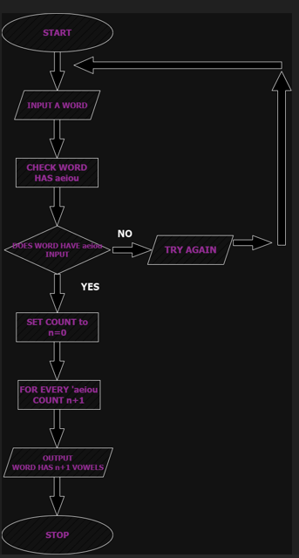

2.4 divisible by 3 and 4
>> Enter a number
>> can the number be divided by 3
>> if no can the number be divided by 4 >>try again
>> if yes can the number be divided by 4
>> if no try again
>> can the number be divided by 3 and 4
>> if yes output this is divisible by 3 and 4
